“kubectl run nginx --image=nginx –port=80”

“kubectl expose pod nginx --type=NodePort --port=80”

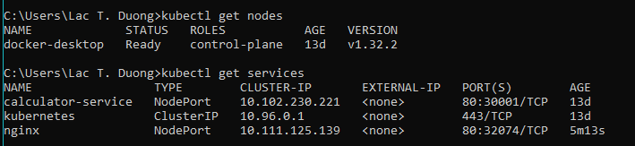

Access via “http://localhost:32074”

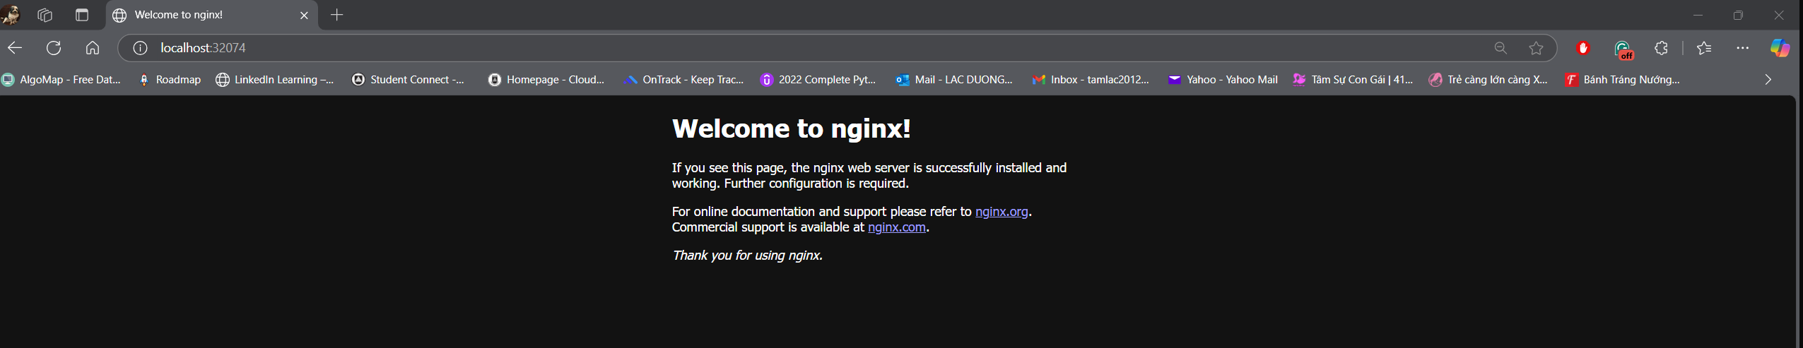

2/ Create simple Secret

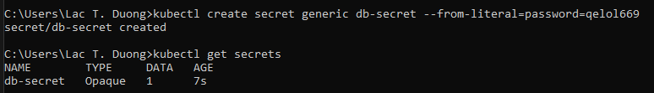

3/ Create simple Flask web application

“http://localhost:5000/book”

4/ Setup PostgreSQL

